**Developing a Selective Laser Sintering 3D Printer for Rapid Fabrication in Wax**

Andreas Bastian

Advising Professors: Lynne Molter and Matt Zucker

October 28, 2011

**Abstract**:  
The Selective Laser Sintering additive manufacturing process is demonstrated with a wax-based print material and an infrared laser.  The 3D-printing device was assembled quickly and easily using low-cost materials and simple tools.  The resulting device is capable of printing complex 3D objects with precision of less than a millimeter and can fabricate objects designed using several common drafting tools as well as those downloaded from the Internet.

**Introduction**

Additive manufacturing processes involve building the fabricated object up layer by layer in a variety of materials.  For instance, in the Fused Deposition Modeling (FDM) technique, an extrusion head is translated while depositing a thin bead of viscous melted plastic, which cools after leaving the extrusion head, hardens, and forms the foundation for the next layer.  FDM is the basis of leading open source (non-commercial, independently-designed) 3D printing technologies such as RepRap, UltiMaker, and MakerBot, which all print in acrylonitrile butadiene styrene (ABS) or polylactic acid (PLA) thermoplastics.

**Motivation**  
 The current leading open source 3D printers print only in ABS or PLA and are restricted both by the limitations inherent in these materials and by the limitations of the FDM process.  Though these printers are entirely capable of self-replication and of producing parts for a variety of light-duty applications, they cannot produce pieces that can replace the cast aluminum parts found in power machinery, CNC equipment, or in numerous other high-strength applications.

**Goals**

The goal of this project is to provide a method for rapidly manufacturing complex pieces in metal by first manufacturing a wax “positive” of the object, which is then used to make a mold for the lost wax casting process.  Current metal rapid manufacturing techniques rely on high-power lasers, plasma jets, or electric arcs to sinter metal powder.  This approach sidesteps the higher costs and dangers of these high-power systems in favor of a relatively low power laser-sintering technique.

*Affordability*

Current open source printer kits range from $1,100 and $1,300, which can be a significant financial impediment.  This system is assembled from salvaged and cheap materials that are easy to work and that yield a high-performance result.

*Open Source*

As this project is the first successful demonstration of an independently produced SLS wax 3D printer, I feel that it is important to share this project, the supporting research, and resulting hardware designs with the rest of the open source hardware and 3D printing community. Sharing simple, cheap, and effective designs like this one benefits the community and allows for other individuals to build off of each other’s work and achieve new and exciting results.

*Interdisciplinary Collaboration*

3D printing is becoming increasingly popular in the arts and I believe that this project is a great opportunity to introduce arts students to some basic engineering ideas and processes through collaborative use of the resulting device. I am working with arts students interested in the project to use the device as a laser cutter. Additionally, the project has provided an opportunity to teach some arts students some basics of microcontroller programming.

**Timeline**

|  |  |  |  |  |  |  |  |  |  |  |
| --- | --- | --- | --- | --- | --- | --- | --- | --- | --- | --- |
| Tasks | 5/29 to 6/4 | 6/5 to 6/11 | 6/12 to 6/18 | 6/18 to 6/25 | 6/26 to 7/2 | 7/3 to 7/9 | 7/10 to 7/16 | 7/17 to 7/23 | 7/24 to 7/30 | 7/31 to 8/6 |
| **1). X-Y Translation System** |  |  |  |  |  |  |  |  |  |  |
| a). Research, design, and purchase materials |  |  |  |  |  |  |  |  |  |  |
| b). Fabrication |  |  |  |  |  |  |  |  |  |  |
| **2). Laser Optics** |  |  |  |  |  |  |  |  |  |  |
| a). Research and design mounts and optics options |  |  |  |  |  |  |  |  |  |  |
| b). Install laser and optics on X-Y translator |  |  |  |  |  |  |  |  |  |  |
| c). Laser characterization studies |  |  |  |  |  |  |  |  |  |  |
| **3). Powder Bed and Reservoir** |  |  |  |  |  |  |  |  |  |  |
| a). Research, design, and purchase materials |  |  |  |  |  |  |  |  |  |  |
| b). Fabricate and test |  |  |  |  |  |  |  |  |  |  |
| **4). Powder Distributor** |  |  |  |  |  |  |  |  |  |  |
| a). Research, design, and purchase materials |  |  |  |  |  |  |  |  |  |  |
| b). Fabricate and install on powder bed |  |  |  |  |  |  |  |  |  |  |
| **5). Software** |  |  |  |  |  |  |  |  |  |  |
| a). Write and distribute software design survey |  |  |  |  |  |  |  |  |  |  |
| b). Work on user interface |  |  |  |  |  |  |  |  |  |  |

Figure 1. Gaant chart depicting the schedule for the project.

**Print Powder**

Beginning in the spring 2011 semester, I conducted an in depth study of the feasibility of wax sintering with lasers of various powers and wavelengths.  The first and most important proof-of-concept task was to demonstrate that a mixture of wax and an energy-absorbing pigment could be reliably sintered together to form continuous “beads” of wax that could be used to build objects. The most important two parameters governing “sinterability” of a given wax mixture were laser power and beam travel speed.  To investigate the relationship between these parameters, I performed several broad tests to establish the basic range of powers and travel speeds and then tested these ranges more thoroughly.  To attain controlled translation speeds, I employed a prefabricated linear translator and later used a modified flatbed scanner.

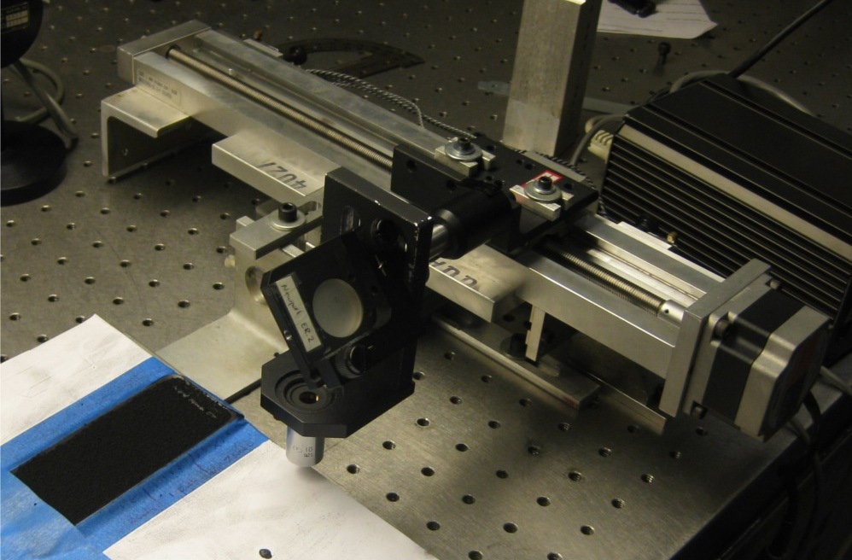

Figure 2.  Original linear translation system with focusing optics.

Using the results of this round of targeted sinter tests, I proceeded to calculate a “sinter-quality factor”, $F_{sq}$, calculated as

$$F_{sq}=\frac{Laser Power (W)}{Beam Area \left(m^{2}\right)*Travel Speed (\frac{m}{s})}= \frac{Joules}{{meters}^{3}}$$

I used $F_{sq}$ to narrow my search to speeds and powers that would yield an $F_{sq}$ of similar magnitude to successful sinters at other speed and power combinations. Using this strategy, I discovered that translating a 1.5-Watt beam at approximately 15 cm/min yielded reliable and consistent sintering.

*Wavelength sensitivity*

Given that pigments best absorb energy from light at particular wavelengths, I investigated infrared (750-1400nm), 532nm, and 633nm lasers for measurable increases in melting power. I controlled for the different energy densities of the different beams by measuring the beam diameter and power, then constricted the beam through an aperture of known diameter and adjusted the laser power to achieve a consistent power density. The apertured beam was then directed onto a bed of paraffin powder mixed with carbon powder and allowed to dwell on a region for a fixed amount of time. I repeated this process for ten durations in one second intervals and determined that the red 633nm HeNe was most effective at melting the wax powder mixture, as can be seen below.

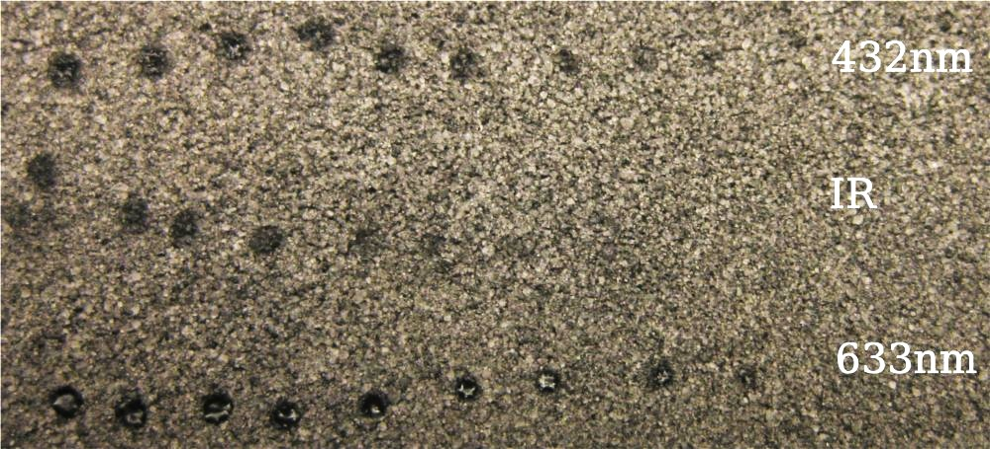

Figure 3. The results of the wavelength sensitivity tests.  Dwell time decreases from left to right from 10 seconds to 1 second.

*Wax Types and Mixtures*

In addition to investigating paraffin wax mixtures, I tested four industrially manufactured fine-grain wax powders for sinterability: carnauba wax, candelilla wax, and two SasolWax wax spray mixtures.  All four industrially produced waxes had very fine grain sizes on the order of tens of microns, which led to fluid-like behavior of the powders and surprisingly low powder density.  The homemade paraffin mixture had a grain size on the order of hundreds of microns that led to a denser mixture, but a lower “print resolution”.  In order to derive accurate results from my sinter tests with these four waxes, I instituted a scale from zero to five of “sinter indices” to quantize and describe the degree of sintering in a given test.  A sinter index of zero indicated a complete lack of continuous bead formation while a sinter index of five indicated the formation of one even, continuous bead.  This scale proved enormously useful in looking for trends in the test results.

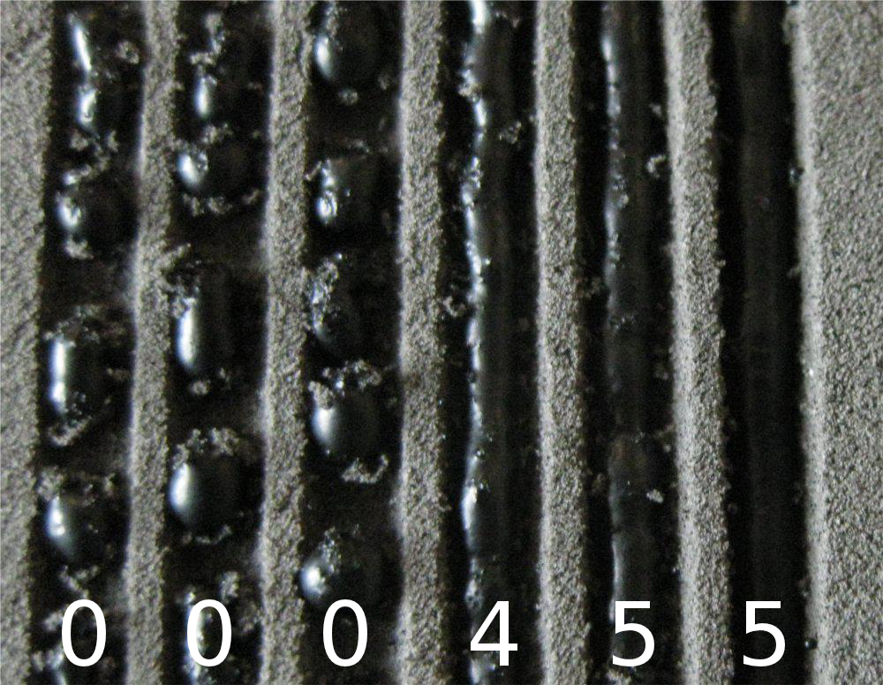

Figure 4.  Candelilla wax sinter test results.  The two beads on the right were assigned sinter indices of five.  The three on the left were assigned sinter indices of zero.

This first series of experiments indicated that a homemade paraffin wax and carbon powder mixture sintered most reliably though it still presented problems when it came to particle size.  During the first half of the summer, I investigated other means of production of the paraffin print powder to further reduce particle size.  I settled on using a homemade ball-mill loaded with dry ice, paraffin prills, and activated carbon powder as my means of fabricating paraffin print powder.  This method yielded powder with a significantly finer grain size than I had previously been able to obtain.  Though this new method reliably produced fine powder, it had very unreliable sintering characteristics.  This and the investigation of a fifth wax, ozokerite granules, led to the discovery that carbon power concentration in the print mixture was far more important than I had originally suspected.  Too little carbon powder and the print powder would form clumps as individual wax particles stuck to each other.  Too much carbon powder prevented the melted wax from forming a continuous bead.  I suspect that the carbon powder on the surfaces of individual wax particles prevented them from coalescing when liquid.  With this insight, I revisited the industrially produced wax powders and quickly discovered a carbon concentration that allowed the reliable sintering of candelilla wax.

*Bead to Bead Sinterability*  
 Once I had established a combination of wax mixture and sinter parameters that worked together well to produce even beads, I investigated the process of fusing beads together to form sheets of wax.   Using the candelilla wax mixture and the appropriate sinter parameters, I was able to sinter a continuous bead, translate the powder bed a distance slightly less than the width of the bead, and then sinter a new bead parallel to the first.  The new bead overlapped slightly with the first and fused to it.  By repeating this process, I was able to sinter a continuous and even sheet of wax.

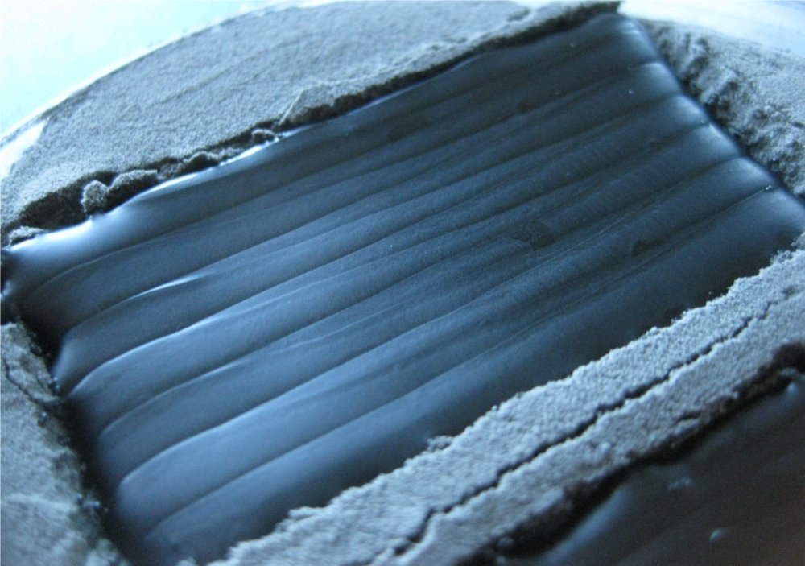

Figure 5.  A layered, sintered sheet of the candelilla wax printing mixture demonstrating the smooth, even surface of the solidified wax.

Next, I spread a new layer of wax powder over a sintered sheet and sintered a new sheet on top of the first.  The layers fused seamlessly, demonstrating that the layer-by-layer fabrication of objects out of sintered wax is indeed possible.

**Hardware**

I broke the hardware into four main design and fabrication tasks:  the 2D translation system, the optics mount and laser shutter, the Z-translation system, and finally the print-powder distribution mechanism.  I approached these components sequentially and with modularity in mind so as to allow further design refinement as the project progressed.  
  
*2D Translator*  
 The 2D translation system went through two design iterations.  The first design employed two re-purposed flatbed scanners, each driving and axis of translation.  This design choice was chiefly motivated by the desire to use salvaged components in an effort to avoid complexity of designing and fabricating a new system from scratch.  Surprisingly, it turned out to be much more complicated to fabricate the various adapters and mechanical parts to interface and support the scanners.  After a month’s work of drafting and machining, I abandoned the flatbed scanners in favor of a much simpler and elegant 2D translation system.

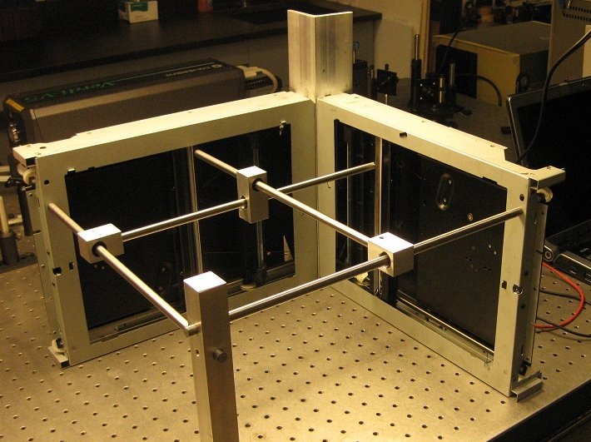

Figure 6. The first prototype 2D translator was made from two salvaged flatbed scanners.

MIT student and graduate Ilan Moyer demonstrated an incredibly elegant, simple, and robust 2D translation system as part of the design work he undertook while enrolled in MIT’s MAS.961:  How to Make Something That Makes (Almost) Anything.  His cable-based system (http://web.mit.edu/imoyer/www/portfolio/foamcore/index.html) can employ a variety of cheap, easy-to-work materials.  He demonstrated the system using foamcore board and plaster as the principle structural materials.  Additionally, the system yields precise, accurate linear motions and thanks to very direct extraction of motion from stepper motors, very little positioning error enters the system.

Having seen the versatility and strength of MDF (medium-density fiberboard) as a construction material for homemade CNC routing machines, I decided to use it as the chief structural material for my project.  For speed of assembly, I used superglue for permanent joints and threaded rod, nuts, and bolts for other joints.  Finally, adhesive-backed Teflon tape proved invaluable as a friction-reducer where MDF surfaces were in moving contact.

The 2D translator’s frame was cut from a single piece of MDF, preventing the introduction of dimensional irregularities from any joining processes.  The square frame’s perimeter was cut to size on a table saw and the interior of the square was removed using a vertical milling machine.

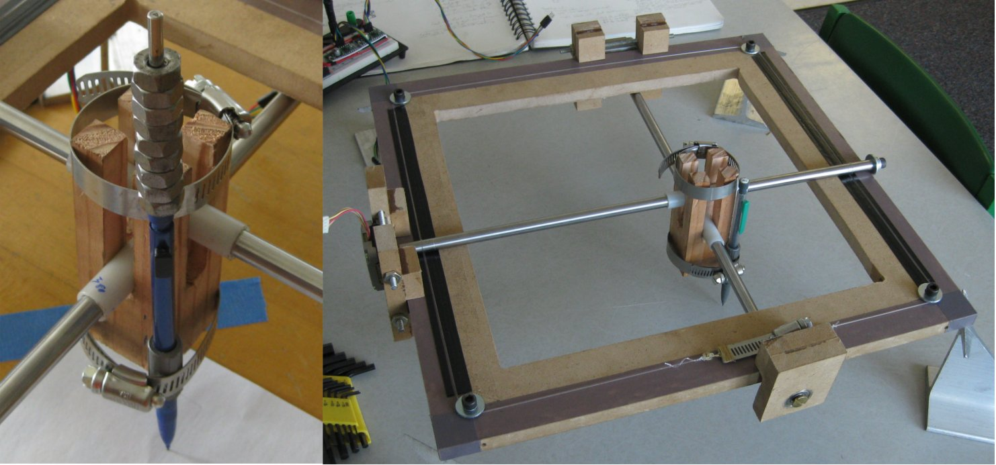

Figure 7. Early version of the translation head, showing the reamed nylon bushings mounted in a block of wood (left) and an overview of the complete translation system (right).

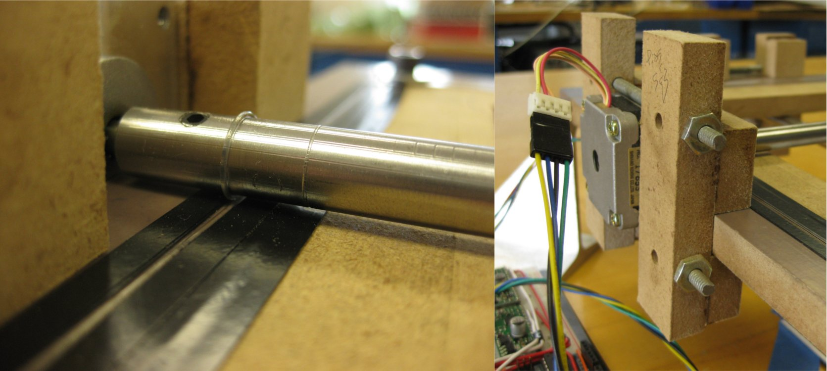

Figure 8. Detail of the cable-wrapping of the gantry rod (left) and one of the two motor mounts used in the translation system (right).

Over the course of the summer, the MDF frame of the translator began to warp under the strain from the tensioned cables, likely contributing inaccuracies to the positional capabilities of the system. The lower gantry rod and cable system was much less reliable than the upper gantry rod and cable system. Because the rod was suspended in the cable, it required a special support fixture at its end, which led to additional friction during translation. The lower rod’s cables also had a tendency to leave their guide grooves and prevent the rod from translating near the limits of the motion envelope by jamming against the guide ridges.

*Feed and Print Pistons*

The feed and print piston parts were cut from ½ inch MDF and assembled with superglue and cap screws.  Additionally, all surfaces subject to sliding motion were coated in Teflon tape.  Each piston is driven by a stepper motor that is bolted to the underside of the piston platform.  This stepper motor is directly coupled to a leadscrew that mates with a captive nut that is fixed in the piston housing structure.  The leadscrew provides smooth linear motion with positioning accuracy in the tens of microns and high load capacity.

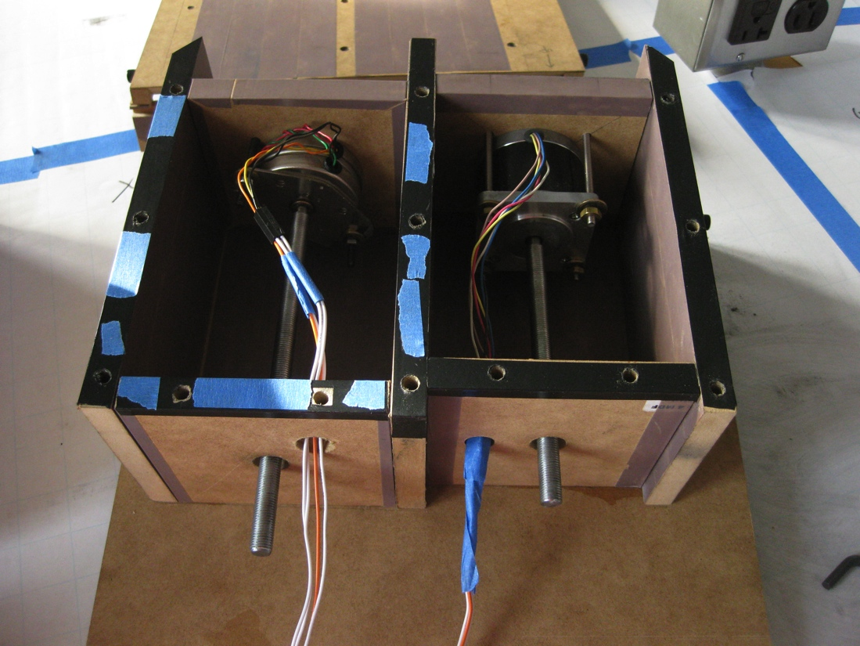

Figure 9. Feed (left) and print (right) piston prototype.

Currently, printed objects have a tendency to warp and curl around the edges away from the print platform’s surface. The cooling of the each new layer causes it to contract slightly, which leads to the inward curling of the edges of the printed object, which are not restrained by the opposing force of a connected neighboring region of sintered wax. The effects of this warping on the printing process can be clearly in Figure 9.

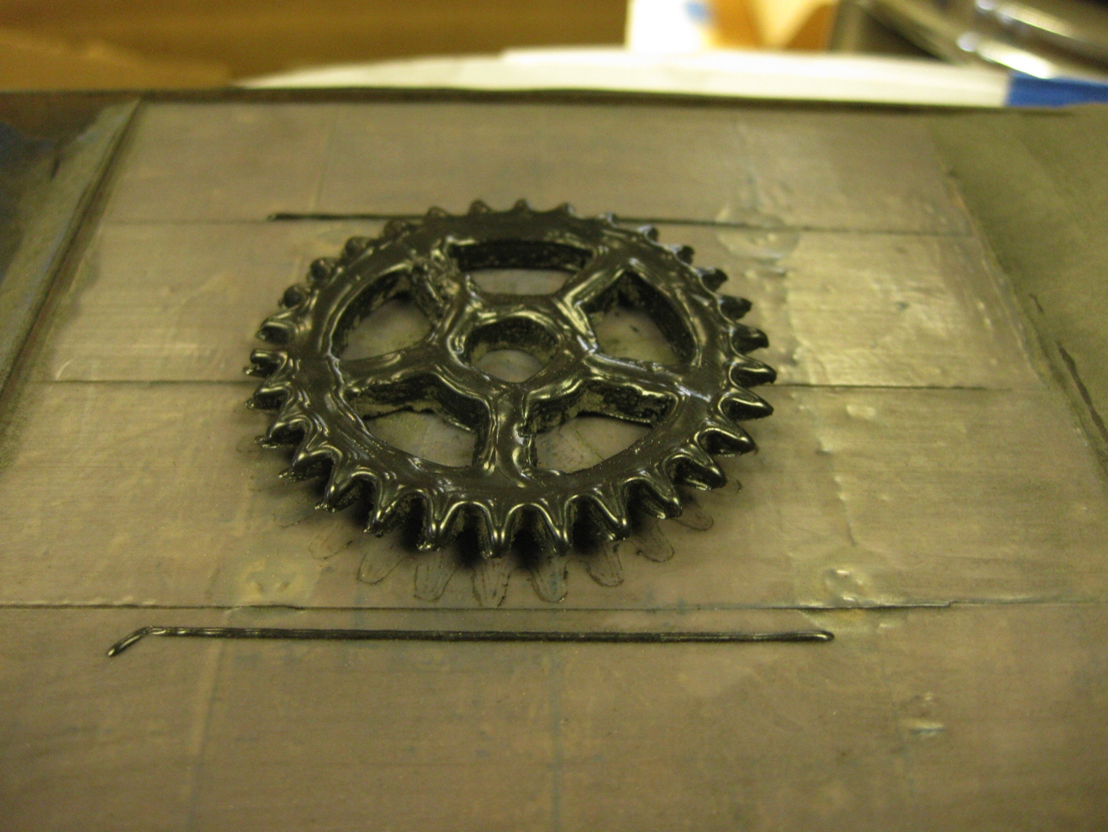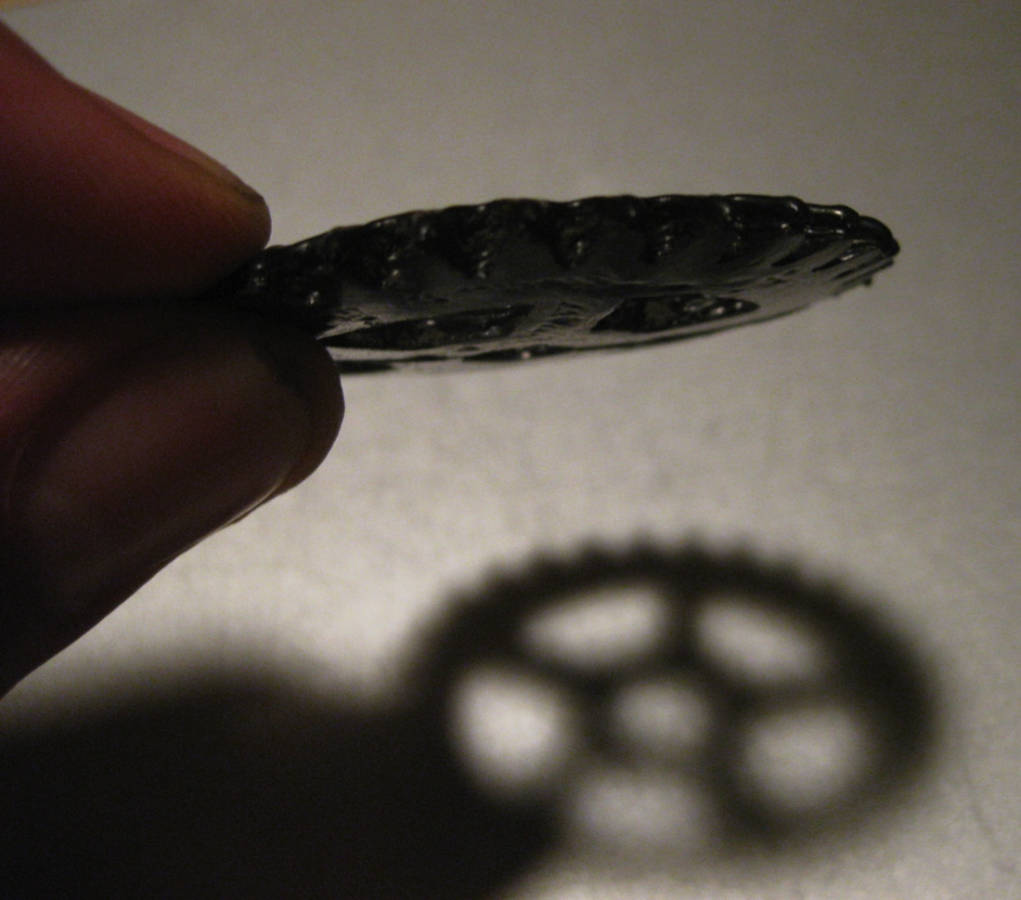

Figure 10. A printed gear, left, and thermal warping of a printed gear, right. The ends of the spurs are significantly less thick than the base.

Here, the perimeter of the gear curled up from the print platform during the print. As the teeth rose, they reduced the amount of powder that could be deposited and sintered onto the previous layer, resulting in teeth with a wedge-shaped cross-section rather than a rectangular one.

The open source FDM 3D printers have encountered similar thermal warping effects with their cooling thermoplastic objects. One solution that works well with ABS and PLA materials is to print a “raft”—a large, low-density matrix of filaments that buffers the thermal exchange between the printed object and the build platform and helps the printed object adhere to the platform. I investigated rafts briefly and did not have any success with them. Wax has a much lower shear strength than ABS or PLA and consequently the printed object still warped and just sheared the raft around its perimeter. This problem warrants further investigation.

*Powder Distribution Mechanism*

The powder distribution mechanism underwent four design revisions and will be subject to further refinement yet.  In my first design, I attempted to apply the cable-gantry rod system that I had used in the 2D translator to both distribute and compact each new layer of powder.  This system failed due to surplus powder compacting and preventing the motion of the roller over its support “wings.”

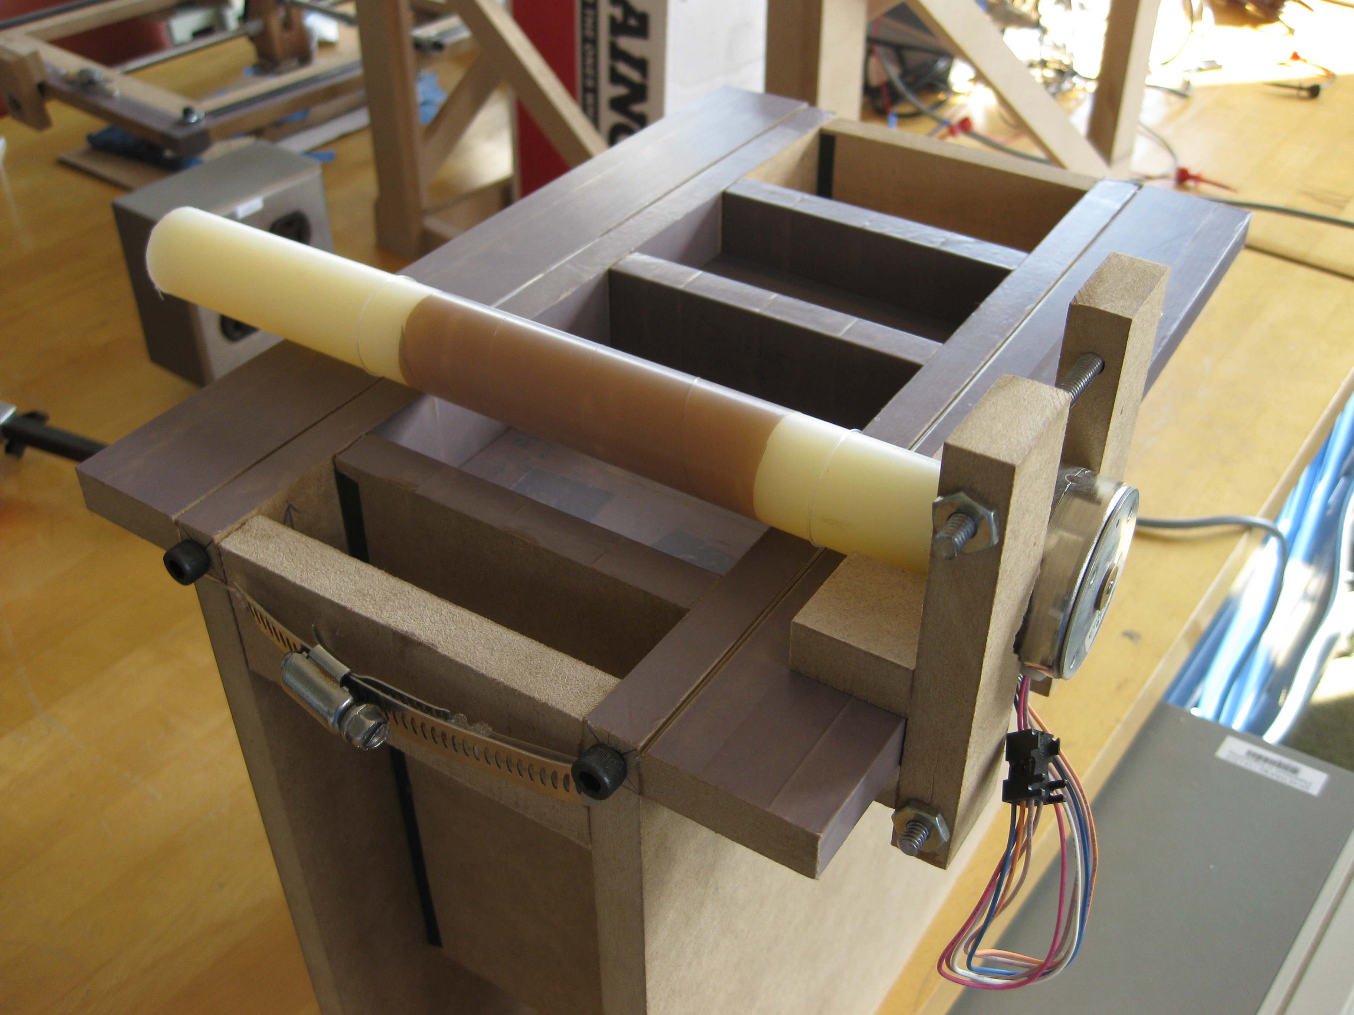

Figure 11. The first, failed powder distribution mechanism.

The second design included beveling the perimeter of the pistons and recessing the divider between the two to avoid compaction issues.  Unfortunately, compaction still proved to be a crippling problem.  Next I tested a “squeejee” method that used a Teflon-coated wedge of MDF to distribute successive layers of powder.  This proved to be very effective and an improved version of this design resulted in reliable print powder distribution when the driving stepper motor was kept cool.

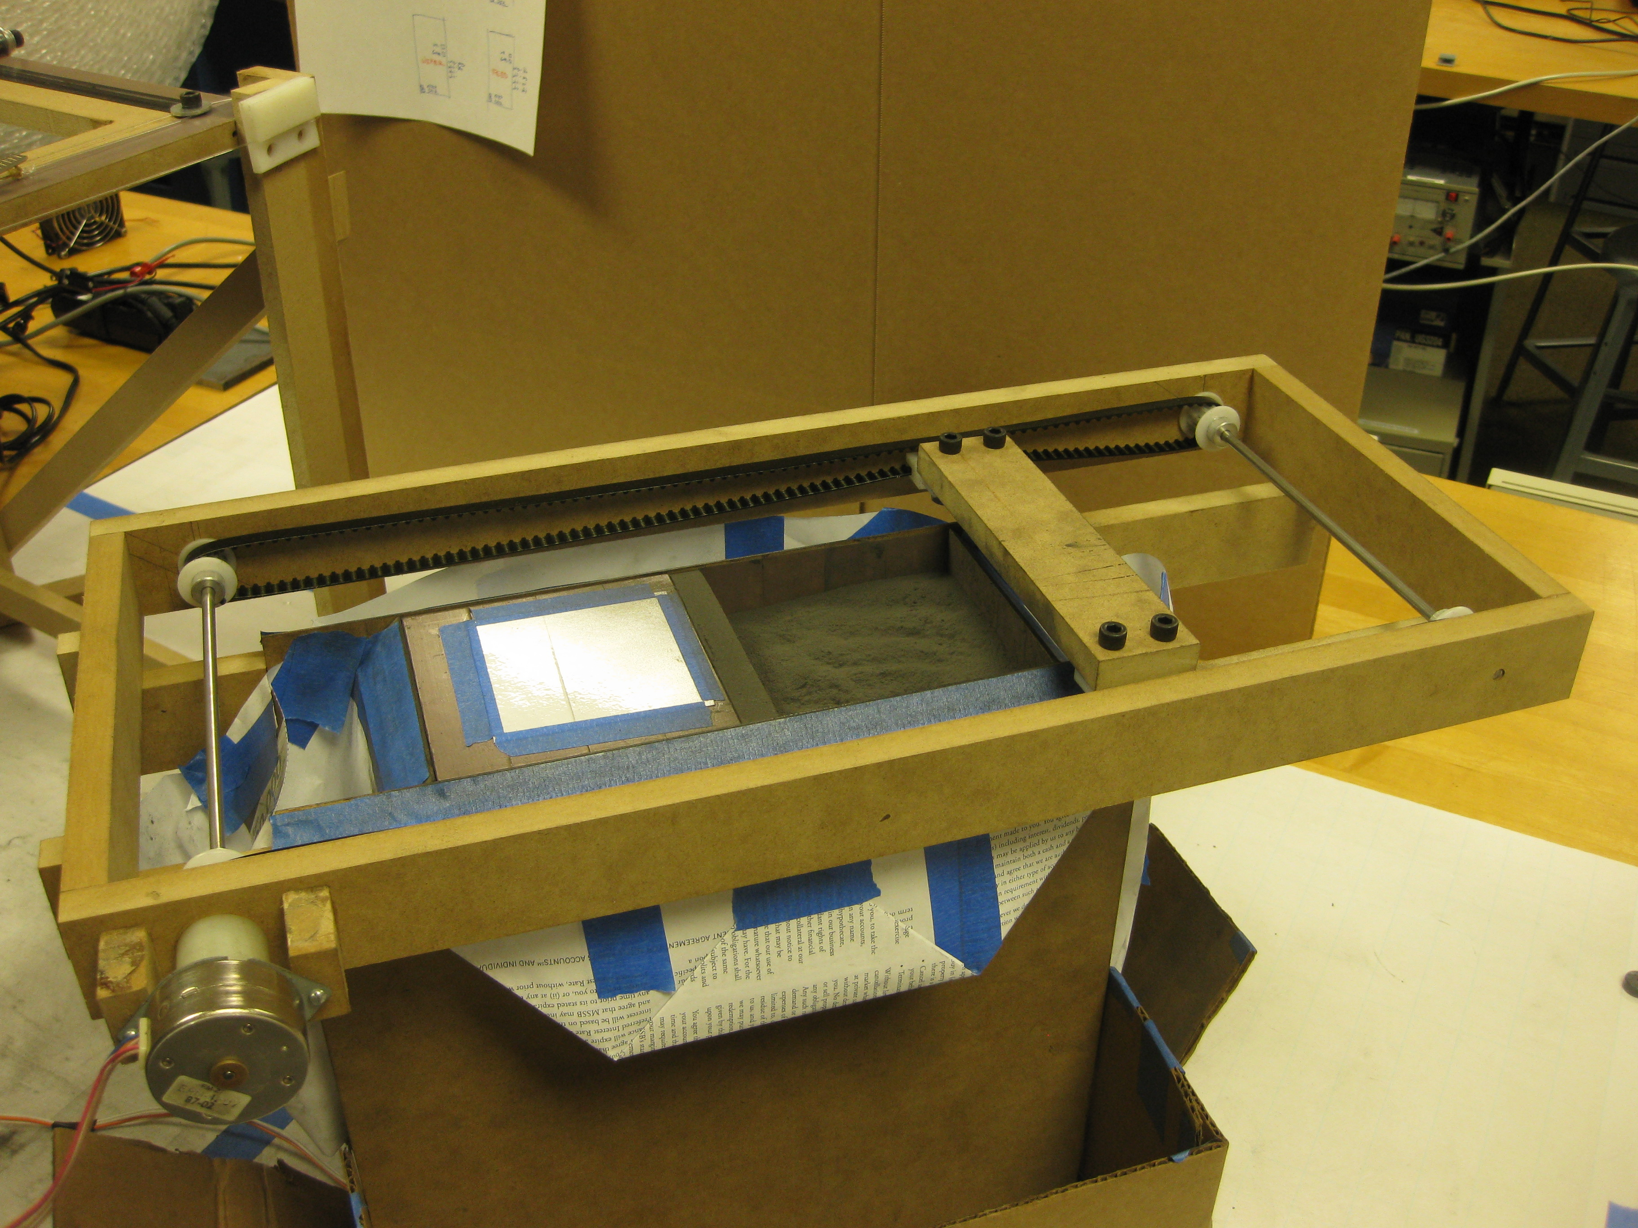

Figure 12. The fourth, and moderately successful powder distribution mechanism.

However, due to tension issues, the teeth on the timing belts occasionally become misaligned with the corresponding notches on the timing pulleys. This misalignment led to periodic increased tension on the belts, which required torque outside of the capabilities of the stepper motor.

*Laser*

This project required a powerful, robust, and affordable laser to melt the wax. I thoroughly explored a variety of commercial and lab-grade lasers suppliers and quickly learned that none of these lasers were in the price range of the project. Fortunately, there is a thriving laser salvage market on eBay and I was able to locate and purchase two 1.5-Watt fiber-coupled infrared lasers at surprisingly low prices. Testing revealed that they were indeed capable of producing the advertised power. The slope of the test current-power curve is constant up to powers of 1.6 Watts, where it begins to plateau, indicating the limit of the laser diode’s output capabilities.

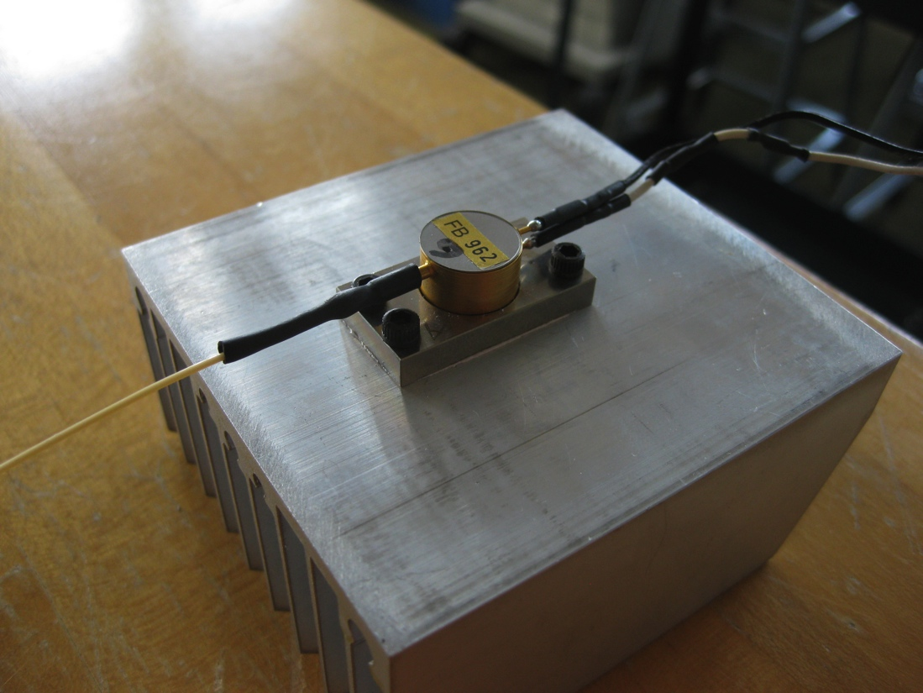

Figure 13. Laser diode affixed to heat sink. The diode is powered by the lines on the right and emits into the fiber optic cable seen at left.

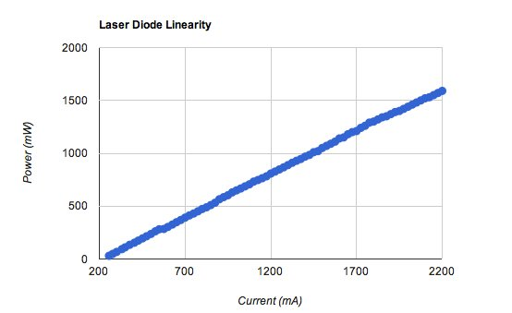

Figure 14. The laser diode behaves predictably linearly up unto 2.2 Amps, where power output begins to decrease.

*Optics Mount and Shutter Mechanism*

I fabricated my first optics mount from 1.5” Teflon round stock on a lathe. The shutter mechanism consisted of a section of bicycle brake cable wrapped in Teflon that was extended into the space between the fiber terminus and the microscope objective that collimated the beam.

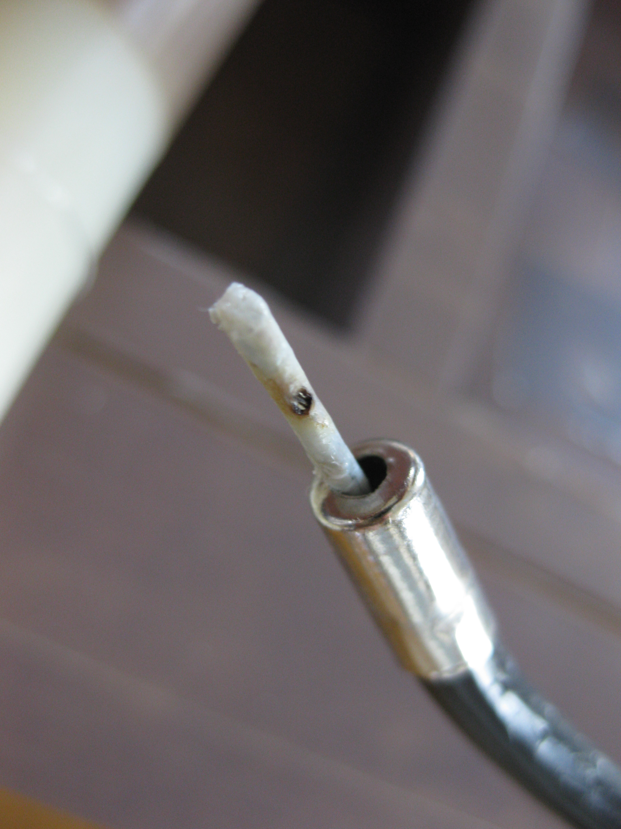

Figure 15. The damaged first shutter.

Due to grit or oil on the Teflon, the laser began to burn through it, which led to condensed Teflon fumes on the fiber terminus and the microscope objective, which severely impaired power density and led to an uneven power distribution within the spot.

The revised optics mount employs a more reliable shutter mechanism as well as a new microscope objective that yields a sub-millimeter spot. The new shutter blocks the beam when the brake cable is actuated by a solenoid, driving Teflon wedge into the shutter plate, pulling the aperture out of the beam path and blocking the beam. Because the brake cable does not have to bend to actuate the shutter, it exerts less force on the translation head, improving accuracy. The microscope objective is held in place inside the Teflon mount by the constricting pressure of a hose clamp after the objective has been adjusted to the proper distance from the fiber terminus.

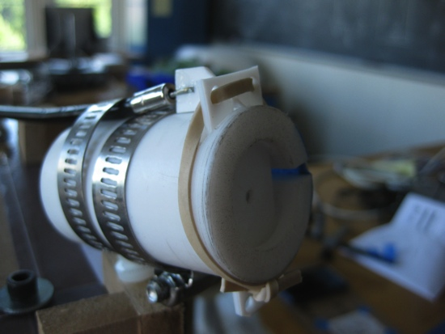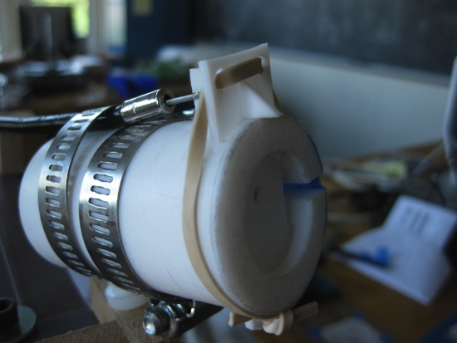

Figure 16. The revised shutter open (left) and closed (right).

**Electronics**

*Development*

I began prototyping the electronics with an Arduino Duemillenove microcontroller and the highly versatile Pololu A4983 stepper motor driver modules. The stepper drivers are perfect for use with salvaged stepper motors because they are capable of delivering step pulses at a variety of voltages up to 2 Amps.

*Current System*

The current system is scaled up version of the early electronics. It employs an Arduino Mega microcontroller, five A4983 drivers, a solenoid control circuit, and a several power supplies. The layout of the system can be seen in the following figure.

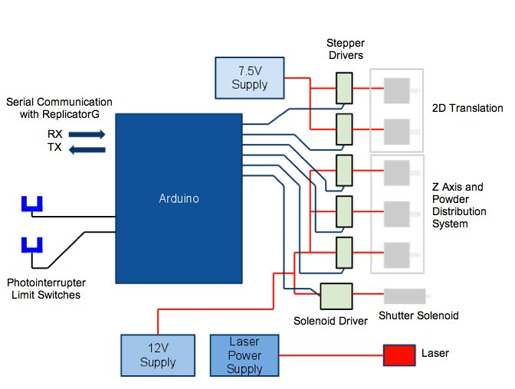

Figure 17. Diagram of the electronics that run the device.

The electronics are very modular and scalable. The Arduino Mega has a wealth of digital I/O pins, which allows for the incorporation of optical limit switches in addition to the five-stepper motors that run the hardware and the laser control solenoid.

*Ongoing Problems*

Though the electronics are robust, they still require several different voltages to run the stepper motors, necessitating individual power supplies for different motors. Additionally, the cost of the laser power supply alone is two to three times the cost of current leading open source 3D printers.

**Software**

*Development*

During hardware construction and testing, I wrote simple programs in the Arduino and Processing languages (essentially C++ and Java, respectively) to control the hardware. My ultimate goal was to write a simple toolset for importing or generating a 3D model of a part, breaking it down into instructions for the hardware, and then transmitting these instructions via serial communications to the microcontroller. I quickly learned that this was a far more difficult task than hardware design and fabrication.

At the suggestion of a fellow student, I looked into the universal CNC machining language GCode. To my surprise, I found a powerful piece of open source software called ReplicatorG that could import .stl 3D model files, manipulate them, and export GCode. This GCode was customized to run common open source 3D printers such as RepRap and MakerBot. More research led me to find a version of ReplicatorG that had been customized to run UltiMaker FDM 3D printers, which employ an Arduino microcontroller in a system very similar to the one that I had constructed. From the UltiMaker website, I downloaded both the customized ReplicatorG software and the pairing Arduino firmware that could parse and execute GCode commands sent from ReplicatorG. Within ReplicatorG lies a very powerful and very configurable piece of open source software called SkeinForge, which is responsible for the GCode generation. I have yet to test all the options within SkeinForge but preliminary exploration of the adjustable parameters indicates that it will likely be possible to increase print quality significantly.

*Current Workflow*

It is very easy to design and print an object using drafting software, ReplicatorG, and modified GCode-parsing firmware. Starting with a pencil sketch, the object can be further refined in autoCAD or Google SketchUp and then exported as an .stl file. This file can then be opened in ReplicatorG and converted into GCode, which can then be sent via a serial line to the Arduino, where the firmware parses and executes the commands.

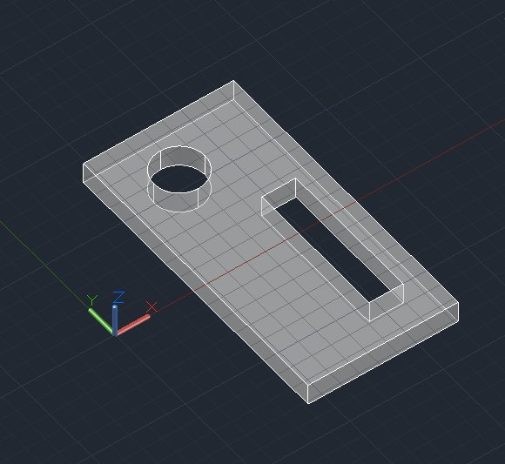 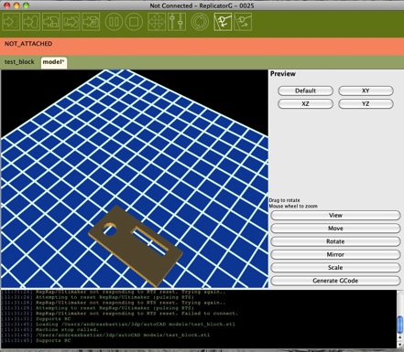

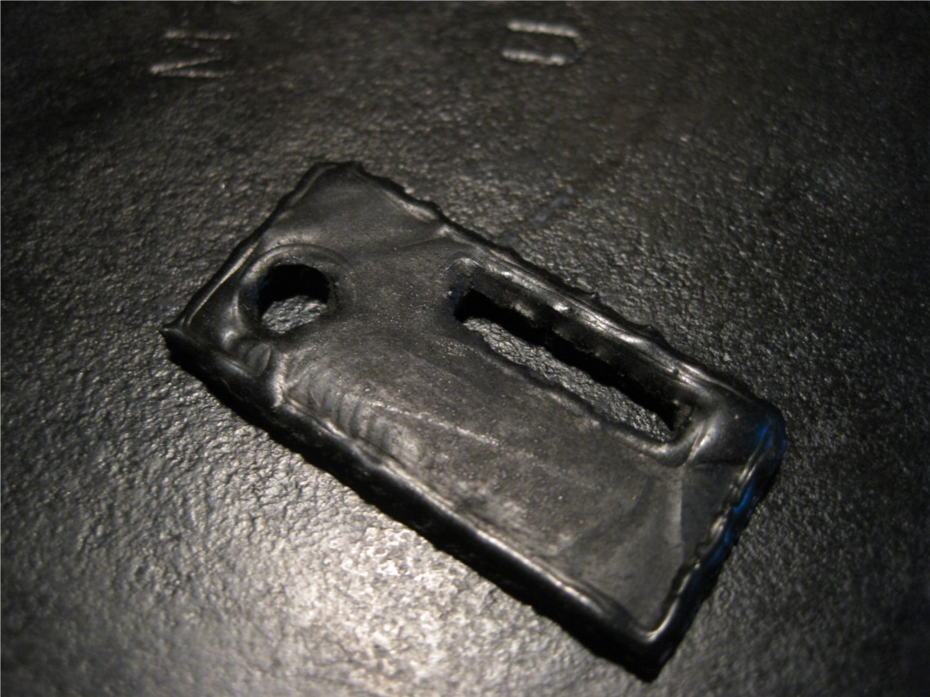

Figure 18. Workflow for designing and printing a simple object. It is first modeled in autoCAD (top left) then imported into ReplicatorG (top right) where it is rendered into GCode. Finally, the GCode is executed on the printer and the object is built (bottom).

*Ongoing Problems*

The software side of the project is fairly robust and easy to use, but there is significant room for improvement in GCode generation in SkeinForge, a piece of open source software that runs inside ReplicatorG.

**Lost Wax Casting**

Using a plaster mold of a simple printed test block, I successfully made a Zinc casting of the wax positive, as shown below.

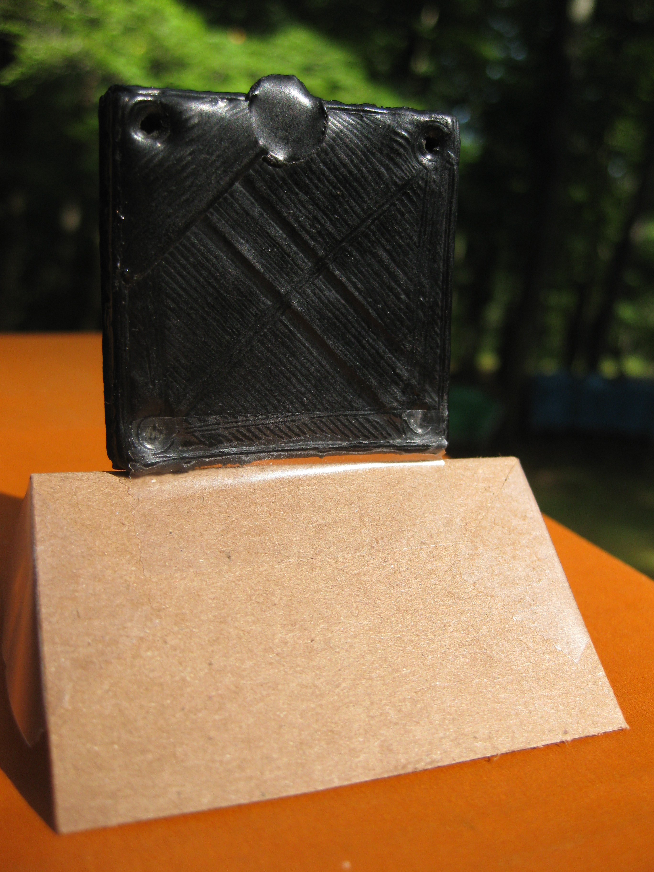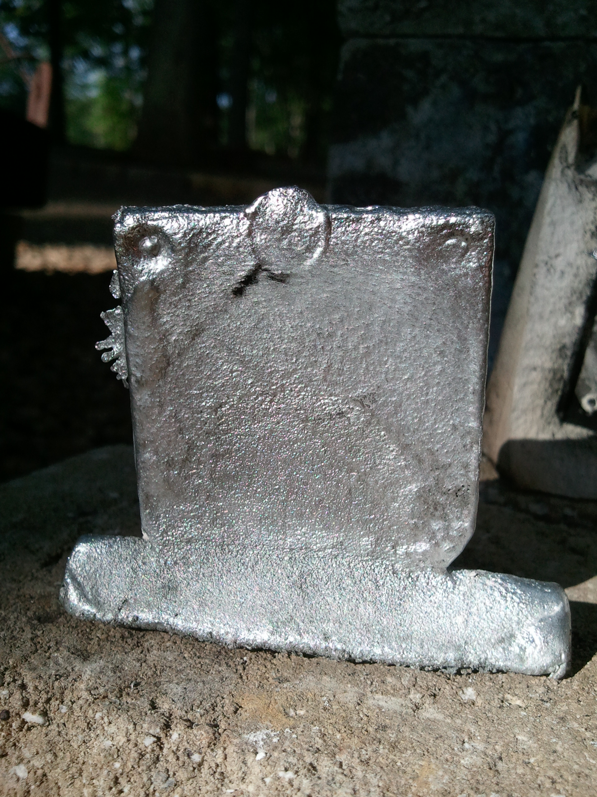

Figure 19. Result of lost wax casting of a printed test block.

The resulting casting was did not have the same detail as the original wax positive, due to residual carbon powder that was left adhered to the inner walls of the mold after the wax wicked into the plaster mold. Additionally, the wax residue in the mold began to combust and release fumes during the pour, which also contributed to some loss of detail.

**Budget**

Compared to open source 3D printers like RepRap, UltiMaker, and MakerBot, which cost between $900 and $1,300, this system is remarkably affordable.

|  |  |
| --- | --- |
| **Item:** | **Cost:** |
| Aluminum angle stock | $30 |
| Steel drill rod | $15 |
| Linear bearings | $120 |
| Stepper drivers | $100 |
| Arduino Mega | $65 |
| Lasers | $198 |
| Brake cable | $15 |
| MDF | $10 |
| Teflon Tape | $40 |
| 5kgs Candelilla wax powder | $95 |
| Sieves | $110 |
| **Total Project Cost:** | $798 |
| **Total Prototype Cost:** | $469 |

**Future work**

*Heated Print Platform*

A heated print piston may solve the thermal warping problems by keeping the printed object at a temperature near the transition temperature of the wax, preventing contraction during printing. This approach was also developed in the open source FDM 3D printing world and has been successfully demonstrated in several models of 3D printer. Additionally, a heated print platform has the potential to reduce print times, allowing the laser to run at faster speeds.

*Improved Powder Management System*

Replacing the current underpowered stepper motor that drives the powder distribution system is absolutely necessary for reliable operation. Additionally, the system would benefit from a belt-tensioning apparatus, which would prevent the timing belt and timing pulley misalignment issue.

*Affordable Laser Power Supply*

The laser power supply is currently the most expensive piece of equipment necessary for the printer’s operation. Used ILX Lightwave precision current supplies range anywhere from $1,800 to $2,250. Additionally, I used five individual adjustable bench-top power supplies to power individual stepper motors, which adds an additional $200 to $300. I think that it is important to investigate options for powering the system with either homemade or salvaged power supplies because these devices are the least affordable elements of the project.

*Improved Translation System*

There is ample room for improvement of the translation system. Replacing the lower, suspended gantry rod and cable system with a second, non-suspended system would prevent the various problems accompanying the suspended rod and would allow for reinforcement of the frame to prevent warping from the cable tension. This new construction technique would also be much easier to scale up, which would allow for a larger print-envelope. Finally, more powerful stepper motors would ensure reliable step indexing.

*Larger Print Envelope*

I successfully demonstrated a small prototype of a leadscrew-driven Z-axis translation system that delivered reliable and precise positioning. A scaled-up print piston would allow for larger, more ambitious prints and dramatically expand the printer’s capabilities as a tool for machine parts production.

*Improved Tool Path Generation*

There is much room for improvement and exploration in tool path generation. Printing times stand to see the most gain from manipulation of GCode generation parameters in SkeinForge. By adjusting infill strategies, it would be possible to reduce time spent sintering the interiors of certain objects. Because these wax objects are destined for the lost-wax casting process, it is not necessary that their interiors be composed entirely of sintered wax. Much of the interior volume could be left as unsintered wax, which still provides some support to the overall structure of the object.

Additionally, it may be possible to implement custom routines to handle specific problems with object geometries. For instance, it is currently still difficult to print a new layer in wax that is not supported by a previous layer below it. By adjusting travel speeds and even laser power to specifically address the unique problems of this situation, it may become possible to print previously impossible geometries.

*Introduction of Engineering Tools and Concepts to Arts Students*

Finally, this project presents an enormous opportunity to communicate some of the basic and fundamental tools of engineering to students from other disciplines. During this project, I talked with an art student who was very interested in using the printer to experiment with small sculpture. Several other art students have expressed interest in using the printer to make work and I think that it would be a great opportunity to promote interdisciplinary collaboration between the departments.

I am working with studio art major Tasha Lewis to use the translation system and laser as a laser-etching or –cutting system. Tasha has been experimenting with laser-cut text to make books and is excited about the possibilities of the hardware and laser as tools for her art.

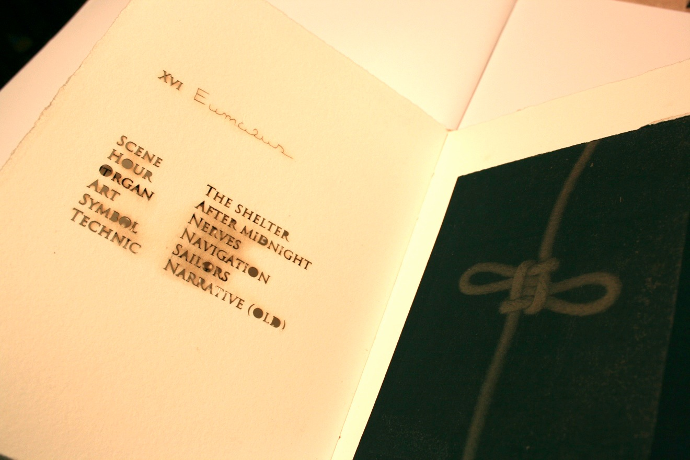

Figure 20. Laser-cut text and cyanotype image from book printed and bound by Tasha Lewis. Made using a commercial laser cutter.

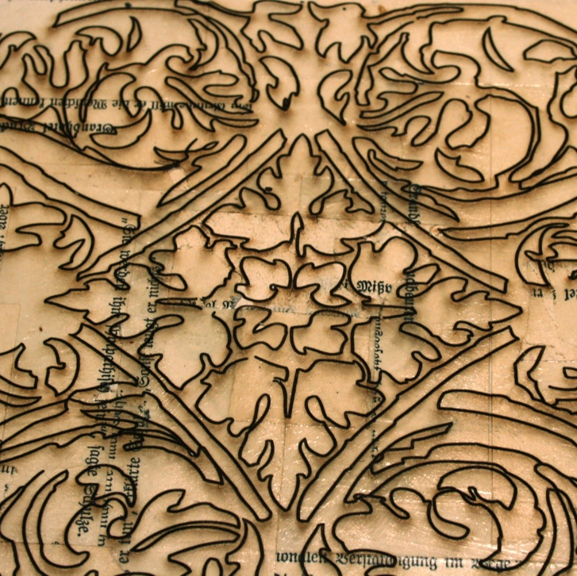

Figure 21. Laser-etched design by Tasha Lewis. Made using a commercial laser-cutter.

In addition to working with Tasha Lewis, I have been working with studio arts major Fanny Zhao to incorporate an Arduino microcontroller into her work. After learning about the role of the microcontroller in the 3D printer, she approached me to learn more about using a microcontroller to read a variety of sensors to control events in her work.

As a ceramics artist myself, I plan to use the 3D printer to make molds and forms for porcelain slip, a liquid form of clay. I am particularly fascinated by the possibility of multi-walled vessels to minimize heat loss and by vessels with intricately finned surfaces.

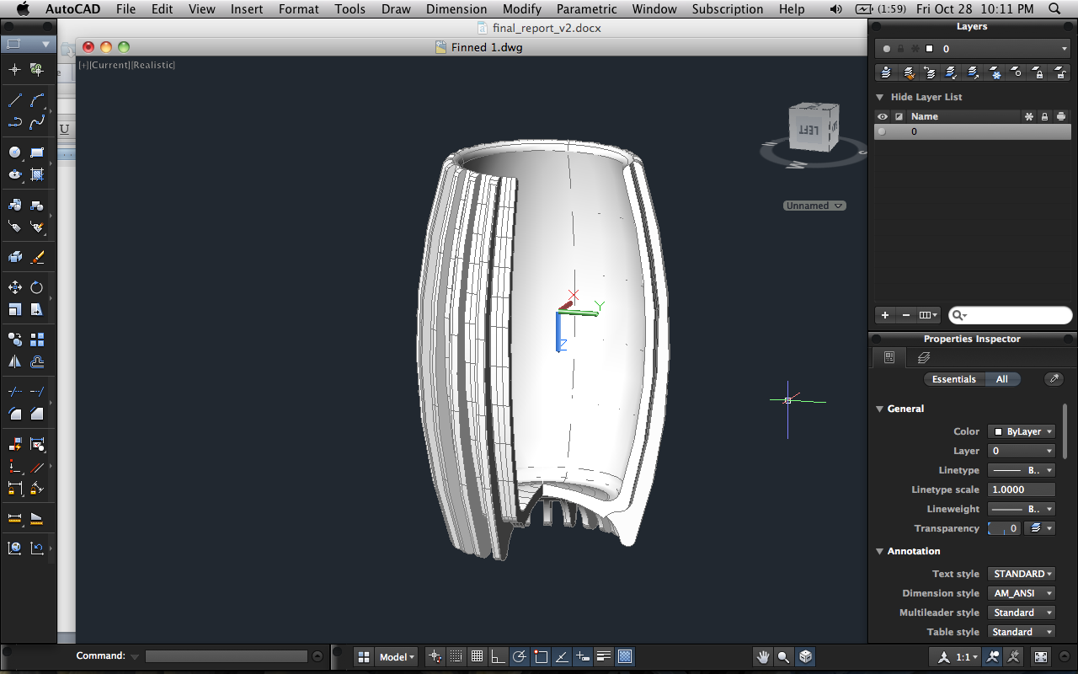

Figure 22. Example of a finned vessel that could be printed in wax and used a mold for porcelain slip.

Though the first prototype of the device was functional, it was not a robust system. In order to continue this project and fully realize its potential as a catalyst for collaboration between students from other disciplines, it is necessary to apply all that I’ve learned from the design, construction, and testing of the prototype printer by constructing an improved version of the printer that is accessible to a larger audience.

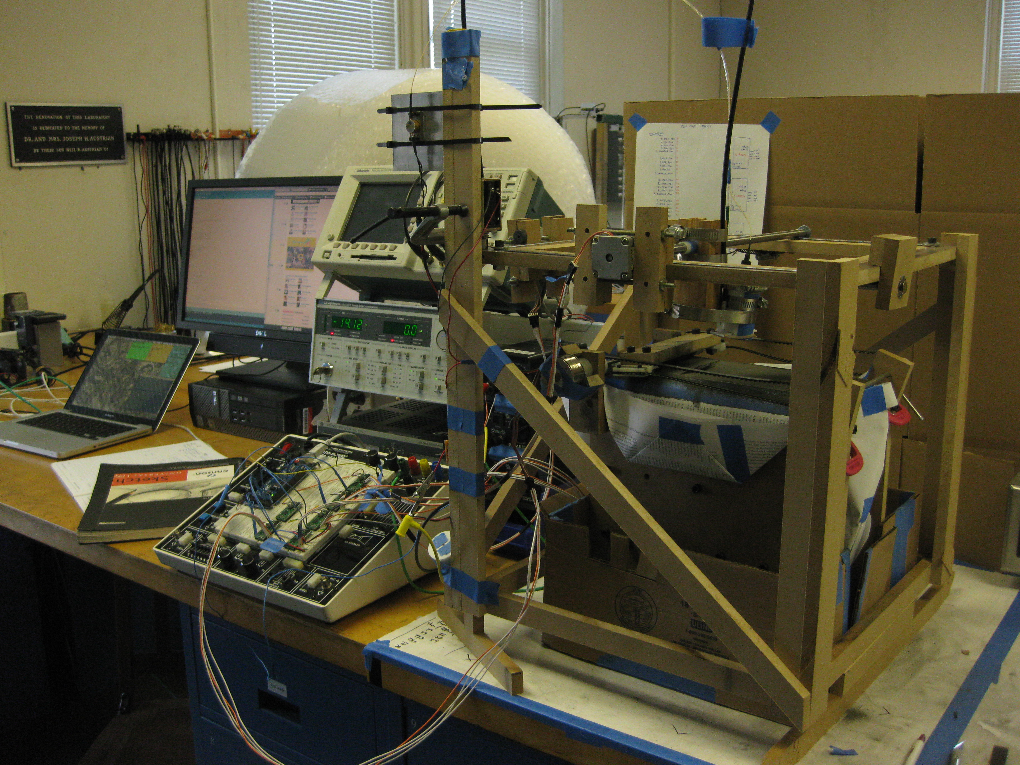

Figure 23. The 3D printer prototype in action.

**Conclusions**

This project successfully demonstrated the selective laser sintering process with affordable print material, hardware, and electronics. The prototype printer was capable of producing relatively complex forms in a material that is compatible with the lost wax casting process. This combination creates a powerful tool for rapid fabrication of complex and durable metal parts.

**Acknowledgements**

I would like to thank the Halpern family for graciously funding my project, Professors Lynne Molter and Matt Zucker for advising throughout the course of the project, Ed Jaudi and Grant Smith for electrical and mechanical advice, Alex Burka ’12 for code troubleshooting assistance, Sam Goldwasser for laser advice, and Alex Long of Strahl and Pitsch for wax samples and technical advice.